HOMEWORK 18

Image Matching

**Student Name**: Rohit Das **Student ID**: 61047086s

**Objective**: Detecting Motion Vectors in two images.

**Algorithm Used**: Traditional Algorithm

* Create the Windowing Function.
* Compare the two image pixel values on the same window.
* Find the Direction.
* Apply Quiver on the image.

**Screenshot of the Algorithm:**

Create the Window:

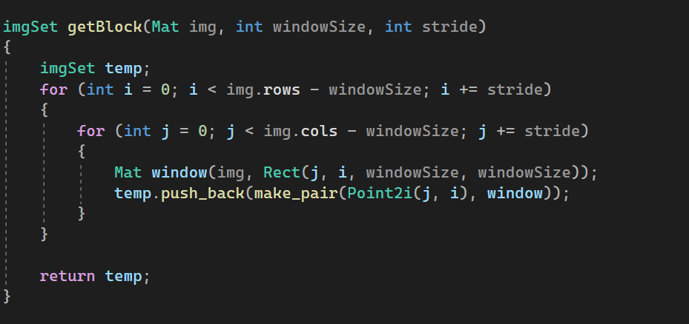

Find the direction of motion

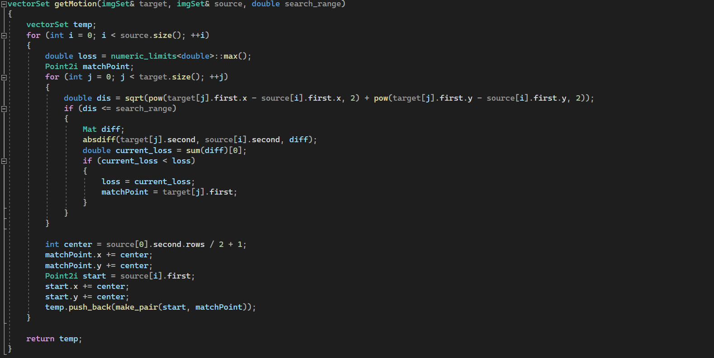

Create the motion Diagram

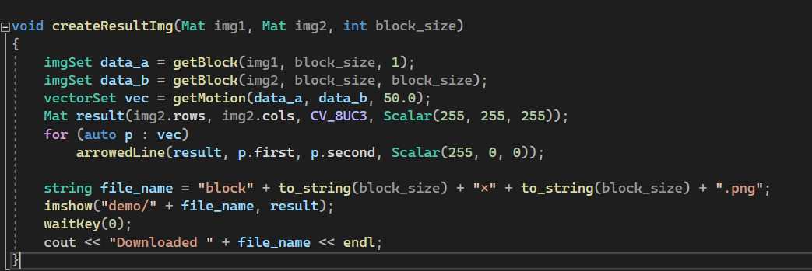

Example Images

1. Using 9*9 Block

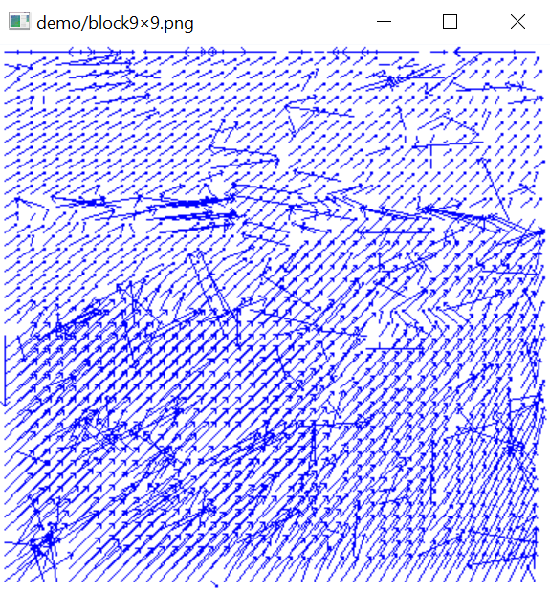

1. Using 11*11 Block

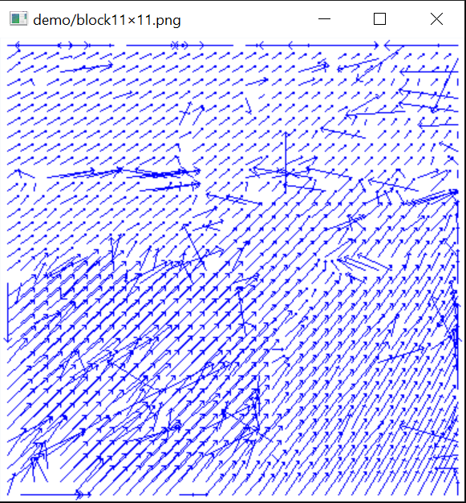

1. Using 15*15 Block

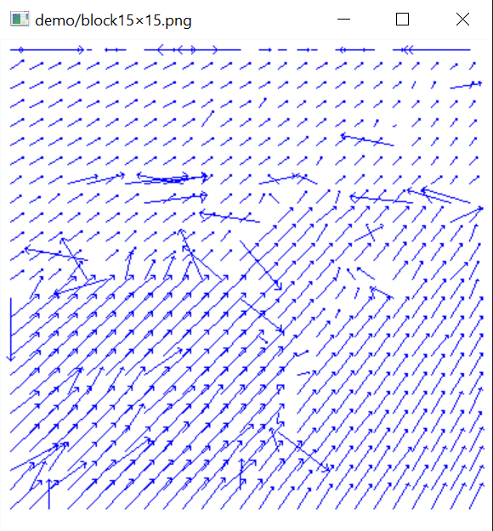

1. Using 21*21 Block

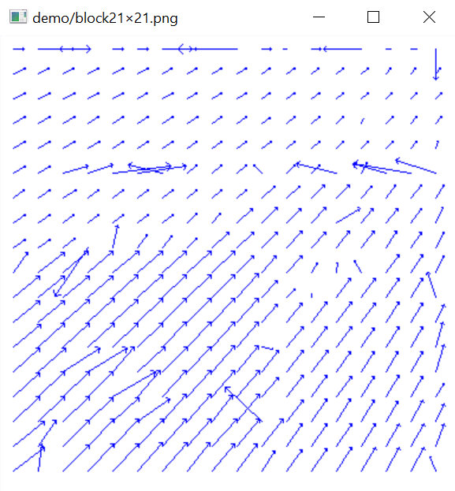

1. Using 31*31 Block

